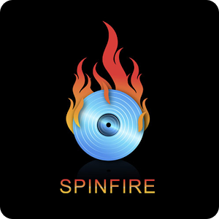

Spinfire Review Guide
Spinfire App for iOS & Android
Requires: iOS 10.0 or later
Requires: Android4.3 and up
Price: Free
Website | App Store | Google Play

Spinfire App - “Where Artists Go to Spin Their Fire”

The Spinfire mobile application gives artists the ability to market their music in clubs by connecting them with club DJs across the nation to purchase spins on demand. Our platform fills a major void in the music industry because we give the independent, aspiring artist a direct and proactive way to market music in clubs. We give them access to the club DJs that they otherwise would not have outside of walking up to the DJ, placing their songs on streaming services, the internet, and or digital record pools. We offer guaranteed, verifiable play in clubs across the county made possible by our patent pending Proof of Play process.

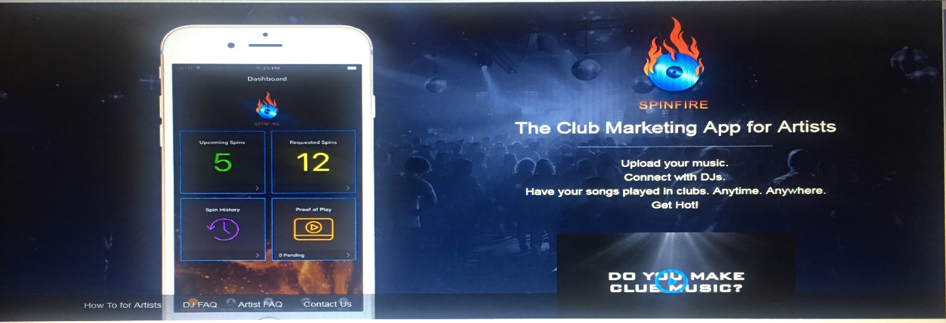

Spinfire Features

Access the hottest DJs everywhere
• Spinfire gives artists access to DJs who spin all genres of music around the globe and who are waiting
to break your new music.
Get your club single played On Demand
• Control your marketing.
• Get your song played On Demand in any club on the hottest nights.
• Order spins today and get your single played to live audiences.
Get your music exposed to nationwide audiences
• Get as much repetition as you need to get your single hot everywhere.
• Reach every city with your music like never before.
Get Instant Feedback to Your Music
• Take your hit single straight from the recording booth into the club.
• Get instant feedback from fans.

Useful Links

iTunes link:
https://itunes.apple.com/app/osnap-perfect-camera-for-selfie/id859025613?mt=8

Spinfire Website:
http://osnapapp.com/

Spinfire Overview Tutorial video:
https://www.youtube.com/watch?v=bKf3UAZCta0
Questions?

If you have any questions, please don’t hesitate to contact
Spinfire Inc - info@spinfireinc.com or 248-595-4894.

For all press and interview inquires please contact
Tia Culver PR - tia@tiaculver.net | 770-896-5685

